|  |  |
| --- | --- |
| Project Title: | Robotic Farm |
| Team Members: | Umur Can Gürelli – Ali Baş |
| Supervisor(s): | Asst. Prof. Dr.-Ing. Özkan Bebiş |

Abstract

Technological applications have being used in agricultural areas in various ways to improve productivity, quality and to decrease huge amount of human effort. While in last two decades; massive development in electrical components providing accessible digital solutions in all fields, technology of farming tends towards to more robotic solutions instead of plain mechanical solutions. This progress in agricultural technology increases quality of products from lots of perspectives like precision, persistence and homogeneity. Also it makes jobs requires overexertion more autonomous. This report describes procedures of design and development of an autonomous robotic solution. This project is a differentiated replica of an open source project called FarmBot. Through report, all design approaches, boundary and operating conditions, cost considerations and prototype process is described with additional elements of project.

Table of contents

1. Introduction and Motivation 3

2. Literature Survey 3

2.1 Aerodynamic performance 3

2.2 Numerical analysis 3

2.3 Optimization 3

3. Definition of the Project 3

3.1 Objectives 4

3.2 Boundary Conditions and Operating Conditions 4

3.3 Constraints 4

4. Methodology 4

4.1 Analysis method 5

4.2 Design method 5

5. Work packages and Time Plan 5

6. Conceptual Design (and /or Results) 5

7. Cost Analysis 6

8. Discussion and Conclusion 6

9. Future Work 7

Acknowledgements 7

References 7

Appendices 8

# Introduction and Motivation

Food production had been most important concern of human history. Unfortunately today’s statistics in agricultural area doesn’t enable us to make good predictions about future.

According to population growth and considering expected quality of food by people, in 2050 required food production will be 70% more than today’s production (Corke, 2015). While demand on food will increase most important supply factor, farmers won’t be enough due to unwillingness of youth generation (White, 2012). This is due to hard labor work of farming and love earning rates. While average age of farmers increases; according to predictions half of the farmers in entire world will be retired in next decade. This will create a big gap between demand and supply chain of food production.

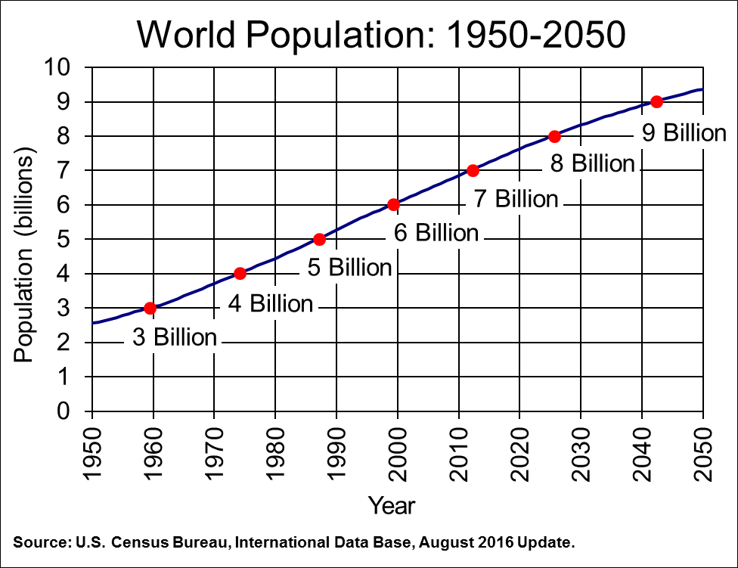

Fig 1. Population growth predictions in 2050

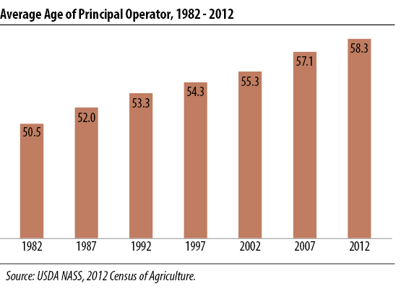

Fig 2. Average age of farmers (United States Department of Agriculture, 2014)

# Fortunately today’s technology creates opportunities for avoiding this result with more autonomous, precise and cheaper farming solutions.

# Literature Survey

## 2.1 Technologies in farming

## There are various new technologies that are used in agricultural fields. However two main approaches can be observed through different system that is developed in last decade.

One of them is autonomous modular vehicles that proceed in open farms and performs various tasks like, grubbing, spraying herbicides, irrigating and transporting of tools. While most advantage of these systems is performing these tasks in autonomous way, also they increase productivity with being smaller than vehicle machines that are used in last decade like tractors and harvesters. Being smaller and modular is crucial for reducing crop rows, roads that are used for movement of farming vehicles without damaging plants. With narrower crop rows and less ground pressure of vehicles; active area of farms can be used more efficiently. (Corke, 2015)

Today there are lots of technologies in robotic vehicles for agricultural like Thorvald Platform; a small modular robotic vehicle which aimed to be used in future farming, Agbot; robotic vehicle for precision agriculture and Frobomind; an open software for creating autonomous vehicles. (Lars Grimstad, Cong Dung Pham, Huynh Nhat Trinh Phan, Pål Johan From, 2015) (Kjeld Jensen , Morten Larsen , Søren H. Nielsen 1, Leon B. Larsen, Kent S. Olsen and Rasmus N. Jørgensen , 2013)

Other technology that is common in field of farming is setups that cover whole area for applying autonomous tasks. These technologies are generally made for indoor and small garden applications. While indoor applications don’t give any solution for future farming problem; these technologies can be scaled up with using vertical farming. Moreover in future some of these projects can be scaled up for outdoor application.

One approach that is applied from MIT Lab, is creating artificial environment to grow wide range of plant kinds. This project aims to create a system that arranges factors affecting plant growth according to selected type plant of user. It is less autonomous in terms of tasks requires human interaction but more flexible in terms of possibilities for growing different plants regardless environment. (OpenAg)

Another technology providing an autonomous setup is created by an entrepreneur is Farmbot. Farmbot is more like a CNC machine or 3d printer that can achieve farming task. In this project a tool mount that can perform different task with different headers moves in three dimensions. (Farmbot)

## 2.2 Phytology Research

## 2.3 Closed Loop System with Step Motors

In this project, movements are made with Step Motors which are designed to be used in open-loop systems due to their non-linear magnetic property. However using feedback signals, desired system can be obtained to achieve position and speed precision. To obtain feedback signal; rotary encoders are used which gives position parameter of gantry and tool mount of system. For system control different method can be used like feedback linearization, sliding mode control, robust control, and backstepping control. (Duane Stort, Mark Ganter, Brian Fabieni, 2014)

In this project for controlling, feedback linearization will be used while there are not disturbance on system and overshoot can be tolerated.

**2.4 Image Processing**

Weeds are one of the harmful elements in agricultures. While today herbicides generally are used, in this system weeds will be pushed to underground via tool mount with weed detection using image processing. In farmbot system there is a camera on mount which monitories garden. With using short and long records of captures weeds can be detected in seconds consistently. Algorithms that can detect weed uses rgb color segment to differentiate weeds and ground. After eliminating earth from visual, it uses edge detection to match similar shapes that is introduced to program. (Ajinkya Paikekari, Vrushali Ghule, Rani Meshram, V.B. Raskar)

# Definition of the Project

Project of this report is designing and prototyping a replica of Farmbot project. Farmbot is complete autonomous setup for performing farming tasks like seeding, irrigating, removing weeds and measuring moisture of soil. Also system has camera for achieving some of these tasks, monitoring plant evolution and recording whole growing process. All of these tasks are made with a tool mount which is compatible with different tools. This tool mount can transform in three axes with gantry robotic system.

While project is building a replica system of an open-source machine, whole design and analyze process are in scope. This is due to reducing cost, increasing efficiency and aim of modification implementations on design according to objectives.

## 3.1 Objectives

The objective of the project is designing and building a prototype of a robotic farm system. Additionally analyzing results of prototype which means examining growth plants is also in scope of this project. Prototype will have capability of growing plants all by itself without human interaction. It will have both indoor and outdoor growing capability. Also prototype will be adjustable in terms of size with applying small changes.

## 3.2 Boundary Conditions and Operating Conditions

The boundary conditions and operating conditions of the above mentioned design objective are provided in Table 1.

|  |  |
| --- | --- |
| **Operating conditions** |  |
| Humidity | Will be decided according to plants |
| Light | Will be decided according to Led system and plants |
| Temperature range | Will be decided according to plants |
| **Boundary conditions** |  |
| Volume range | 30 rpm |
| Speed of Gantry robotic arm | 100 m |

Table 1 Operating and boundary conditions

## 3.3 Constraints

This project has some challenges and constraints in terms of technical aspects, economical aspects and physical applicability.

While robotic technologies include wide range of different disciplines, some technical area won’t be involved in advance. For building a working prototype; applications require knowledge of those disciplines will be obtained from FarmBot’s open source project. Mostly those technical areas will be related to software platform of prototype like image processing, web and application interfaces and computational system design.

This project is granted with 400$. However firm who build this project commercially sells it by around 3000$. According to components list and research raw cost reduced to 560$ which also exceeds granted price. However this cost can be reduced with obtaining hardware components like step motors, single-board computer and microcontroller; from individual resources of project owners.

Even so this project based on robotics, it is also depends on botanical factors. These factors creates some constrains to system. While this system can’t simulate all kind of enviorenments; its capability of growing plants depends on environmental factors. Event humidity, temperature, light can be arranged according to needs of plants up to a point; it can’t provide these factors in all levels. Factors that excluded from scope of project also bring some limitations; like sickness of plants, insects etc…

There are no social and ethical constraints and concerns about this project.

# Methodology

## 4.1 Analysis method

Analyze process will be made iteratively before starting to build system during design process.

Following aspects aimed to be analyzed:

* Stress analysis of rails and gantry frame analytically.
* Analytic predictions of control systems.
* Design analysis with numerical methods using special software..
* Numerical analysis of control systems. (Numerical analysis aimed to be performed with Python(x,y))
* Experimental analysis of planting with general methods before starting to planting using farmbot.

## 4.2 Design method

Project will be designed after obtaining sufficient result from numerical and computational analysis.

# Work packages and Time Plan

Table 1 shows time line of project with work packages and task distribution between project owners.

Work packageleri aç!!!

|  |  |  |  |  |  |  |  |  |  |
| --- | --- | --- | --- | --- | --- | --- | --- | --- | --- |
|  | Oct | Nov | Dec | Jan | Feb | Mar | Apr | May | Task Distribution |
| Background Research |  |  |  |  |  |  |  |  | Ali – Umur |
| Evaluation and Deciding on Project |  |  |  |  |  |  |  |  | Ali – Umur |
| Literature Survey |  |  |  |  |  |  |  |  | Ali – Umur |
| Deciding on Design Methodology |  |  |  |  |  |  |  |  | Ali – Umur |
| Preparing and Confirming Component List |  |  |  |  |  |  |  |  | Ali – Umur |
| Mechanical Design |  |  |  |  |  |  |  |  | Ali – Umur |
| Software Design |  |  |  |  |  |  |  |  | Ali – Umur |
| Design and Thermal Analysis |  |  |  |  |  |  |  |  | Ali – Umur |
| Purchase of components and hardware |  |  |  |  |  |  |  |  | Ali – Umur |
| Building system |  |  |  |  |  |  |  |  | Ali – Umur |
| Software integration |  |  |  |  |  |  |  |  | Umur |
| Test - Planting |  |  |  |  |  |  |  |  | Ali – Umur |
| Analysis of Results (Harvesting) |  |  |  |  |  |  |  |  | Ali – Umur |

Table 2 – Gann Chart

# Conceptual Design (and /or Results)

While this stage is too early for providing a solid conceptual design; prototype will be look like to design provided with Image 1. This design taken from FarmBot project and it can be redesigned completely while this is early stage of the project.

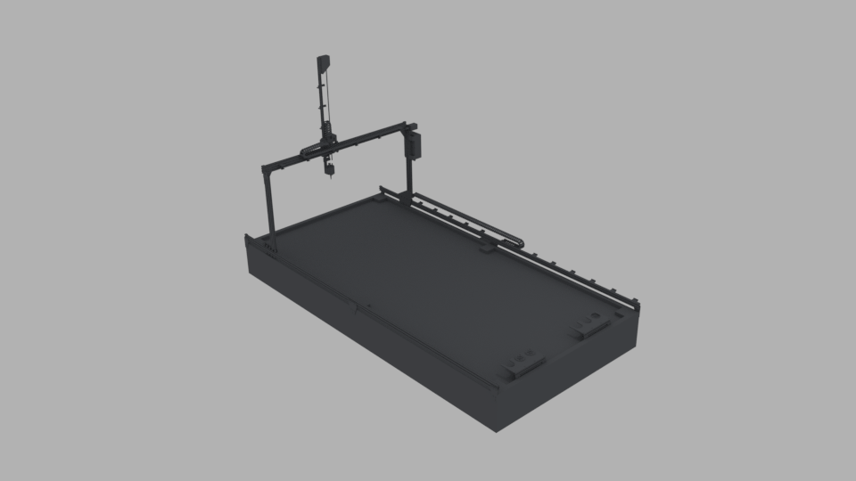

Picture 1

# Cost Analysis

While there is only component list of project cost analysis made roughly and it will be manipulated according to needs and conditions. Component list provided in appendixes. Total current cost is nearly 560$.

Acknowledgements

This project is based on Farm Bot open source project that is developed by FarmBot Inc. (Farmbot)

References

Ajinkya Paikekari, Vrushali Ghule, Rani Meshram, V.B. Raskar. (n.d.). *WEED DETECTION USING IMAGE PROCESSING.*

Corke, P. (2015, 11 13). Robots in agriculture. *[Video file]. Retrieved from https://www.youtube.com/watch?v=Q69RVHy-Xbw*.

Duane Stort, Mark Ganter, Brian Fabieni. (2014). *Closed-Loop Control of a 3D Printer Gantry.*

Farmbot. (n.d.). Retrieved from Farmbot: https://farmbot.io/

Harper, C. (2015, 10). This computer will grow your food in the future. [*Video file]. Retrieved from http://www.ted.com/talks/caleb_harper_this_computer_will_grow_your_food_in_the_future*.

Kjeld Jensen , Morten Larsen , Søren H. Nielsen 1, Leon B. Larsen, Kent S. Olsen and Rasmus N. Jørgensen . (2013). *Towards an Open Software Platform for Field Robots in Precision Agriculture.*

Lars Grimstad, Cong Dung Pham, Huynh Nhat Trinh Phan, Pål Johan From. (2015). *On the design of a low-cost, light-weight, and highly versatile agricultural robot.*

OpenAg. (n.d.). Retrieved from Open Agriculture: http://openag.media.mit.edu/

United States Department of Agriculture. (2014, 5). *Farm Demographics - U.S. Farmers by Gender, Age, Race, Ethnicity, and More.* Retrieved from Census of Agriculture: https://www.agcensus.usda.gov/Publications/2012/Online_Resources/Highlights/Farm_Demographics/

White, B. (2012). *Agriculture and the Generation Problem: Rural Youth, Employment and the Future of Farming.*